9/27/2023

IOT281 - Homework

Jibo Robot

**Lecturer:**

Melary M. Magorimbo

**Students:**

Oliver Gobey – 577644

Hrudhay Reddy – 577833

Liam Conybeare – 577221

Felix Mandyme – 577922

Calvin Jordaan – 577859

Ian Lidzhegu – 577183

Tiaan Kritzinger – 577643

Tyrone Joshua Coles - 578013

Table of Contents

1. Introduction: 2

2. What were the possible motivations for making the product? 2

3. Description on how the product works? 3

HOW THE PRODUCT INTERACTS WITH PEOPLE: 3

HOW THE PRODUCT WORKS INTERNALLY: 3

4. What SCP capabilities does it have? 4

5. Is there a market for this in South Africa? 4

6. Conclusion: 5

7. References: 6

# Introduction:

The following presentation is about an Internet of Things (IOT) product called “Jibo”. Jibo is a personal assistant robot for the whole family and during this presentation information will be discussed about, motivations for creating such a product, how the product works and its functionalities, what Smart Connected Product (SCP) capabilities does it have and if there is a market for the Jibo robot in South Africa.

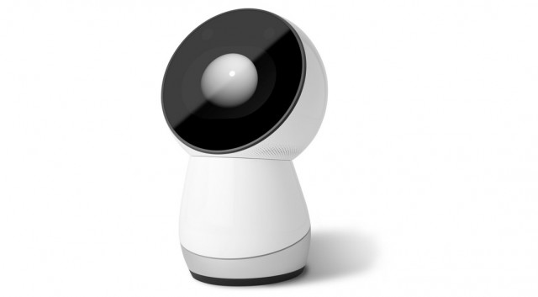

Figure : Picture of Jibo, (Olumide, 2014)

# What were the possible motivations for making the product?

Jibo being a robot assistant, can have a lot of motivation for being a product that people would want to buy, here are some of the reasons this product was created:

* **Source of information or education:** The ability to answer a wide variety of questions and help students with work that they are struggling with.
* **Entertainment:** Creates a joyful environment that the whole family can enjoy.
* **Companion:** Gives a helping hand by sending messages or doing task you are not able to do at that given moment.
* **Adaption:** In a world where there is a lot of change taking place the product should be able to adapt to its given environment.
* **Socially interactive:** The ability to interact with people and respond to them in a way that is meaningful.
* **Staying connected:** Avoid missing important messages and staying up to date with the latest news.



Figure : Example of Jibo interacting with a family, (ROBOTS, 2023)

# Description on how the product works?

Jibo has many features and can constantly learn new skills. The main functionality of Jibo is that he acts as an assistant, but he also has other tricks up his robot sleeves:

## HOW THE PRODUCT INTERACTS WITH PEOPLE:

* He can take pictures and videos.
* Jibo can send and receive messages.
* He can answer a wide variety of questions and can also help students with homework.
* The robot can entertain people by telling them stories or jokes or it can even dance for them.
* People can also use Jibo when video calling, giving the perception that the person is really in the room interacting with the other members of the family or group.
* In the future Jibo might be able to connect to your home allowing it to do other commands, for example: Turning the lights on and off, turning on the radio or television and interacting with other kinds of appliances.

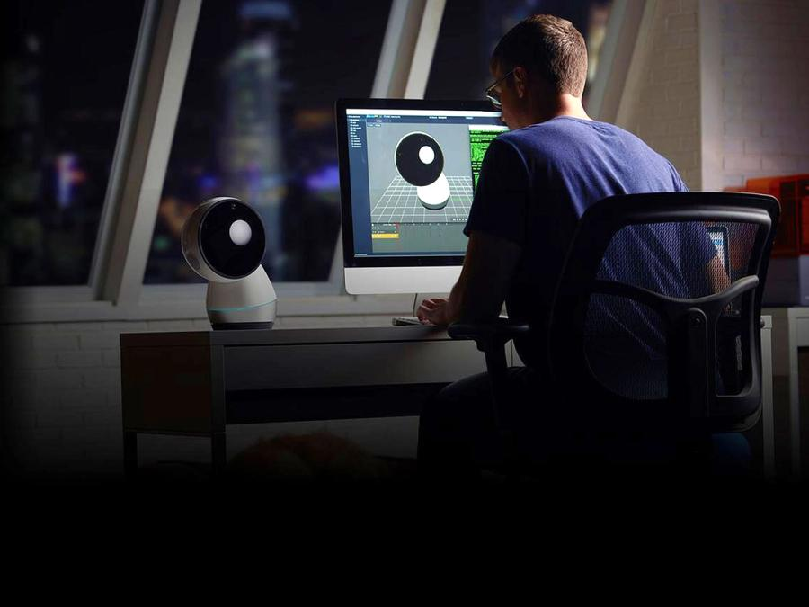

Figure : Example of developers adding new features to Jibo, (ROBOTS, 2023)

## HOW THE PRODUCT WORKS INTERNALLY:

The Jibo Smart Robot works thanks to a combination of hardware and software:

* **Hardware**: It's equipped with cameras, microphones, and sensors that help it see and hear what's happening around it. This allows it to recognize faces, gestures, and voices.
* **Software**: Jibo's software includes advanced natural language processing and speech recognition, enabling it to understand and respond to user commands and engage in conversations. It can also perform tasks like setting reminders, playing music, and answering questions.
* **Facial Recognition**: Jibo can recognize and remember faces, making its interactions personalized.
* **Emotional Expression**: It has a screen that displays animated expressions to convey emotions, making interactions more engaging.
* **Internet Connectivity**: Jibo connects to the internet, allowing it to access information and services in real-time.

# What SCP capabilities does it have?

The robot assistant has the following Smart Connected Product (SCP) capabilities:

* **Monitor:** Jibo has 6 microphones allowing it to move to direction a sound comes from. It also has two cameras; one is for perceiving the distance of an object and facial recognition. The other camera is used for taking pictures. These sensors allow the robot to observe what is happening in the environment around it and allows it to give a proper response to what it is perceiving.
* **Control:** The robot can interact with human conversation and can respond to question that it was given from the user. In the future Jibo might be able to interact with other home appliances.
* **Optimization:** Jibo can constantly learn new skills and can remember users, with the use of facial recognition, allowing it to adapt to specific user preferences.
* **Automation:** Jibo is an autonomous robot that uses its cameras and microphones to coordinate itself so it can look at the person who is talking to it. It can also search for answers on its own, enabling it to give a response to a user’s question. The robot can give its own responses to more personal questions but will most likely answer it in a jokingly manner because it is not able to comprehend human emotions.

# Is there a market for this in South Africa?

Jibo is a very interesting product and has a lot of features that could be fun for all households but given the price of $900 US dollars it is not a product that everyone would buy. Jibo is still in development and although there are a lot of interesting features, there are still some that have not been added. The future for this robot assistant is unknow, because in 2019 its servers was shut down and if it was not for NTT Disruption, the current owners Jibo, Jibo might not have existed anymore. NTT Inc have their own idea for the Jibo robot by focussing more on education and healthcare (Marco, 2020).

With phones also having personal assistants, like Bixby and Siri or other competitors like Amazon, that have Alexa, it is a difficult market for Jibo. People who have interacted with Jibo was not very impressed, as there was a lack in features that were promised and although there were some features that were nice to have, it did not make up for all the missing ones. For all the mentioned reasons, there is not a market for Jibo in South Africa currently. In the future Jibo might be more affordable and being owned by another company it might get other features that will create a larger market for it in South Africa.

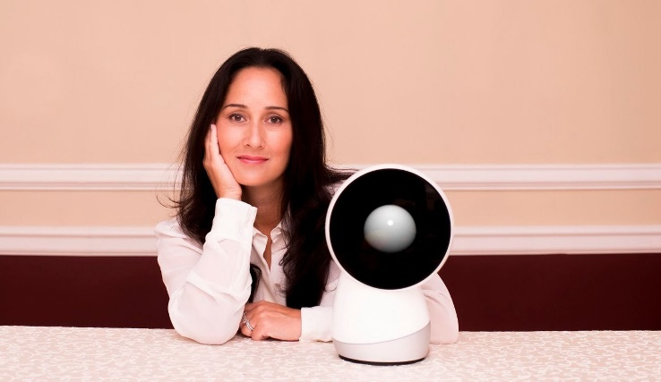

Figure : Cofounder of Jibo Cynthia Breazeal, (Pinterest, 2016)

# Conclusion:

This concludes the presentation of the Jibo, the robot assistant. It has a lot of functionality but requires a lot of care and updates to get it to a point where every household has one. Although Jibo had its ups and downs, as technology is drastically evolving and getting better Jibo might become more relevant in the future.

# References:

innovation top, 2015. *JIBO: The World's First Social Robot for the Home.* [Online]   
Available at: https://youtu.be/H0h20jRA5M0  
[Accessed 26 09 2023].

Linus Teck Tips, 2017. *TERRIBLE $900 Party Trick – Jibo Review.* [Online]   
Available at: https://youtu.be/U1RASlbIIVc  
[Accessed 26 09 2023].

Marco, 2020. *Jibo social robot “reborn” and is coming back!.* [Online]   
Available at: https://www.personalrobots.biz/jibo-social-robot-reborn-and-is-coming-back/  
[Accessed 26 09 2023].

Olumide, 2014. *Meet Jibo, The World’s First Family Robot.* [Online]   
Available at: https://www.informationng.com/2014/07/meet-jibo-the-worlds-first-family-robot.html  
[Accessed 26 09 2023].

Pinterest, 2016. *Jibo: The World's First Social Robot for the Home.* [Online]   
Available at: https://za.pinterest.com/pin/223772675212936314/  
[Accessed 26 09 2023].

ROBOTS, 2023. *Jibo.* [Online]   
Available at: https://robotsguide.com/robots/jibo/  
[Accessed 26 09 2023].